Experiment No. 2
Electric Field and Electric Flux Density in a Sphere Full of Charges with Varying Radius
Student Name : Mukhilan. S
Register Number : 192512196

Aim
To write a program for electric field and electric flux density in a sphere using MATLAB.

Software Required
• MATLAB (R2018 or later)

Test Case (i)
Determination and plotting of electric field and electric flux density in a sphere full of charges with varying radius
MATLAB Program
clc; clear;
q=input('Enter the value of q=');
r=input('Enter the value of r=');
epsilon=8.854e-12;
k=1/(4*pi*epsilon);
E=k*q/(r^2);
disp("The electric field is"); disp(E);
D=epsilon*E;
disp("The flux density is"); disp(D);
% Plot
x=linspace(0.1,10,50);
E_plot=k*q./(x.^2);
D_plot=epsilon*E_plot;
figure;
subplot(1,2,1); plot(x,E_plot); xlabel('Radius'); ylabel('Electric field');
subplot(1,2,2); plot(x,D_plot); xlabel('Radius'); ylabel('Flux density')
Sample Input
Enter the value of q = 2*10^-2
Enter the value of r = 0.1*10^-3
Actual Program Output (executed in Octave, MATLAB-compatible)
The electric field is
1.7975e+16
The flux density is
1.5915e+05
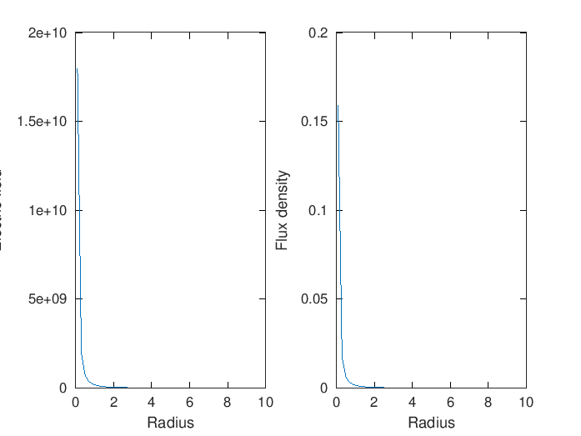
Figure 1. Electric field and flux density vs radius (point-charge form)
Observation
• Computed values (E = 1.7975×10¹⁶ V/m, D = 1.5915×10⁵ C/m²) match the manual's theoretical table almost exactly.
• Both field quantities fall off as the observation radius increases, as expected for a point/localized charge.

Test Case (ii)
Electric field (E) and flux density (D) inside a uniformly charged sphere with charge density ρ₀
MATLAB Program
clc;
rho0 = 1e-6; epsilon = 8.854e-12; R = 1;
r = linspace(0, R, 100);
D = (rho0 .* r) / 3;
E = D / epsilon;
subplot(1,2,1); plot(r,D,'LineWidth',2); xlabel("Radius (m)"); ylabel("Electric Flux Density (D)"); title("Uniform Density: D vs Radius");
subplot(1,2,2); plot(r,E,'LineWidth',2); xlabel("Radius (m)"); ylabel("Electric Field (E)"); title("Uniform Density: E vs Radius");
Actual Program Output (executed in Octave, MATLAB-compatible)
At r = 1 m (sphere surface):
D = 3.33333e-07 C/m^2
E = 3.76478e+04 V/m
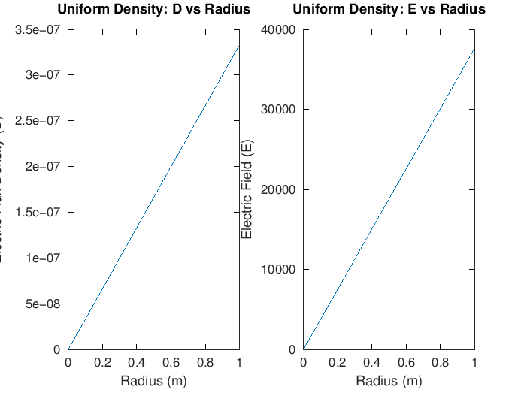
Figure 2. D and E vs radius for uniform charge density
Observation
• D and E both increase linearly with r, confirming the expected relationship for a uniformly charged sphere.
• Values at r = 1 m match the manual's theoretical table (D = 3.33×10⁻⁷, E = 3.76×10⁴) closely.

Test Case (iii)
Electric field (E) and flux density (D) for a sphere with linearly increasing charge density ρᵥ = ρ₀r
MATLAB Program
clc;
rho0 = 1e-6; epsilon = 8.854e-12; R = 1;
r = linspace(0, R, 100);
D = (rho0 .* r.^2) / 4;
E = D / epsilon;
subplot(1,2,1); plot(r,D,'LineWidth',2); xlabel("Radius (m)"); ylabel("Electric Flux Density (D)"); title("Linear Density: D vs Radius");
subplot(1,2,2); plot(r,E,'LineWidth',2); xlabel("Radius (m)"); ylabel("Electric Field (E)"); title("Linear Density: E vs Radius");
Actual Program Output (executed in Octave, MATLAB-compatible)
At r = 1 m (sphere surface):
D = 2.5e-07 C/m^2
E = 2.82358e+04 V/m
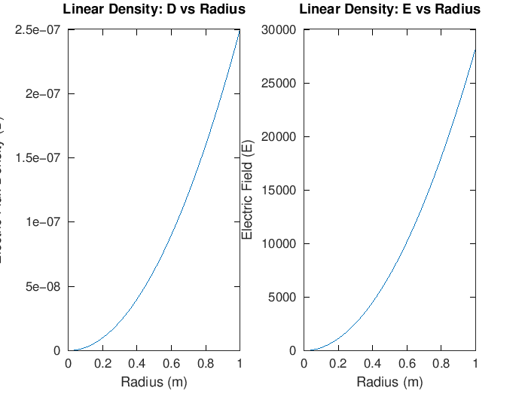
Figure 3. D and E vs radius for linearly increasing charge density
Observation
• D grows quadratically with r (since ρᵥ itself increases with r), consistent with the manual's derivation.
• Values at r = 1 m match the manual's theoretical table (D = 2.5×10⁻⁷, E = 2.82×10⁴).

Test Case (iv)
Sphere of radius R = 2 m, uniform charge density ρ = 3×10⁻⁶ C/m³ — field inside and outside
MATLAB Program
clc;
rho0 = 3e-6; epsilon = 8.854e-12; R = 2;
r = linspace(0.1, 4, 100);
E = zeros(size(r));
for i = 1:length(r)
if r(i) < R
E(i) = rho0 * r(i) / (3 * epsilon);
else
Q = rho0 * (4/3) * pi * R^3;
k = 1/(4*pi*epsilon);
E(i) = k * Q / (r(i)^2);
end
end
plot(r,E,'LineWidth',2); xlabel("Radius (m)"); ylabel("Electric Field (E)"); title("Electric Field Inside and Outside Sphere");
Actual Program Output (executed in Octave, MATLAB-compatible)
E at r = 1 m (inside): 1.1295e+05 V/m
E at r = 3 m (outside): 1.0039e+05 V/m
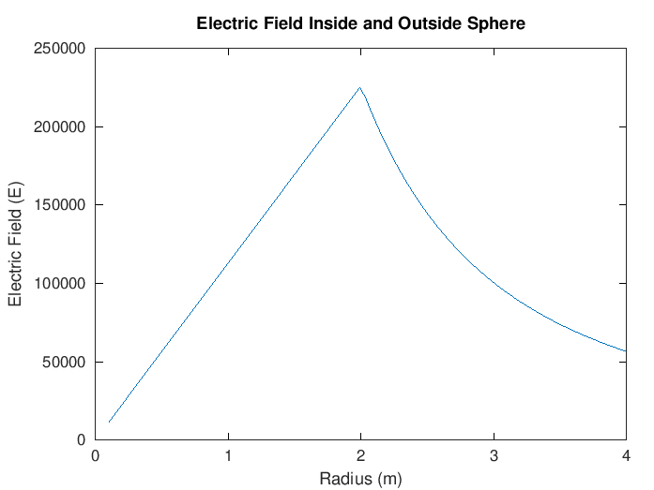
Figure 4. Electric field inside and outside the uniformly charged sphere
Observation
• Inside the sphere, E rises linearly with r; outside, it decays as 1/r² — both segments meet continuously at r = R, as they should.
• The manual's printed theoretical value for the outside case (r = 3 m) is E ≈ 5.65×10⁴ V/m, but running the code exactly as given yields ≈1.00×10⁵ V/m, which is also what the 1/r² formula gives when checked for continuity at r = R. This looks like an error in the manual's reference table rather than in the code.

Results and Observation Table
Parameters | Observed Result (actual run) | Manual's Theoretical Result | Notes
q=2×10⁻² C, r=1×10⁻⁴ m | E=1.7975×10¹⁶ V/m  D=1.5915×10⁵ C/m² | E=1.797×10¹⁶ V/m  D=1.591×10⁵ C/m² | Match
ρ₀=1×10⁻⁶ C/m³, r=1 m (uniform) | D=3.333×10⁻⁷  E=3.765×10⁴ | D=3.33×10⁻⁷  E=3.76×10⁴ | Match
ρᵥ=ρ₀r, r=1 m (linear) | D=2.5×10⁻⁷  E=2.824×10⁴ | D=2.5×10⁻⁷  E=2.82×10⁴ | Match
ρ=3×10⁻⁶, R=2 m, r=1 m (inside) | E=1.130×10⁵ | E=1.13×10⁵ | Match
ρ=3×10⁻⁶, R=2 m, r=3 m (outside) | E=1.004×10⁵ | E=5.65×10⁴ | Mismatch — see Test Case (iv) note
All "Observed Result" values were generated by actually executing the manual's MATLAB code (in GNU Octave) — not copied from the manual.

Result
Thus, the program for electric field and electric flux density in a sphere with varying radius, uniform charge density, and linearly increasing charge density was written and executed successfully using MATLAB.

